**EYFS**

|  |  |  |  |  |  |
| --- | --- | --- | --- | --- | --- |
| **Autumn 1** | **Autumn 2** | **Spring 1** | **Spring 2** | **Summer 1** | **Summer 2** |
|  |  |  |  |  |  |

**Y1/2 YEAR A (starting 2022 – 2023) * Spring 2 will need substituting for the first cycle with “There’s a tiger in my garden”**

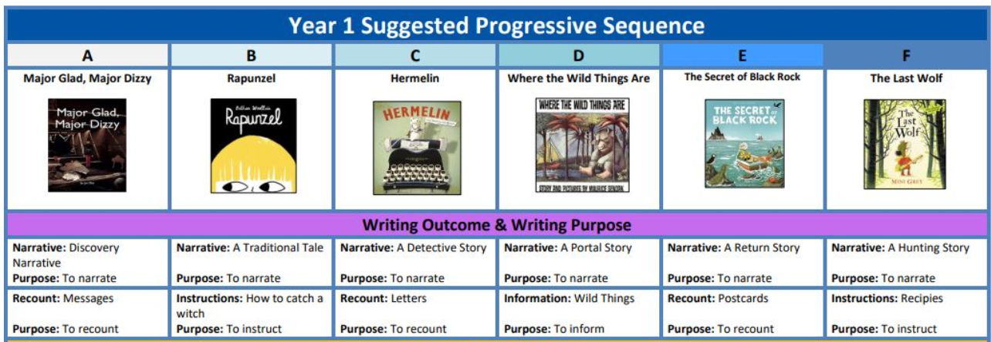 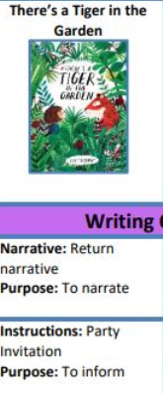

**Y1/2 YEAR B (starting 2023 – 2024)**

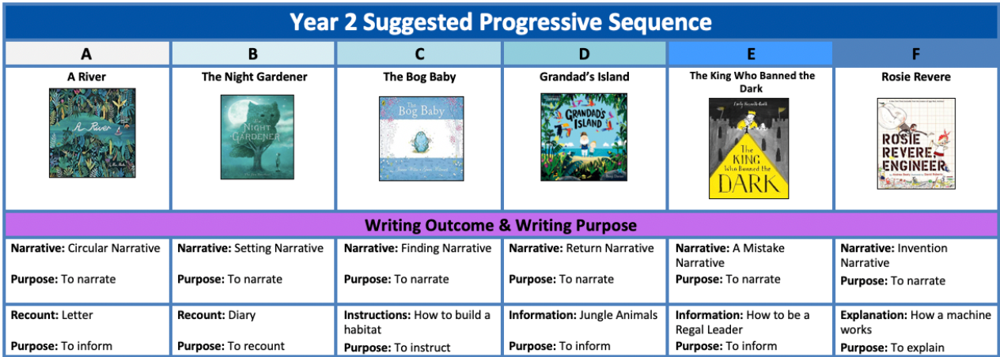

**Y3/4 YEAR A (starting 2022 – 2023) * Autumn 1 will need substituting for the first cycle with “seen not heard”**

|  |  |  |  |  |  |  |
| --- | --- | --- | --- | --- | --- | --- |
|  |  |  |  |  |  |  |

**Y3/4 YEAR B (starting 2023 – 2024)**

|  |  |  |  |  |  |
| --- | --- | --- | --- | --- | --- |
|  |  |  |  |  |  |

**YEAR 5/6 YEAR A (starting 2022 – 2023)**

|  |  |  |  |  |  |
| --- | --- | --- | --- | --- | --- |
|  |  |  |  |  |  |

**YEAR 5/6 YEAR B (starting 2023 – 2024)**

|  |  |  |  |  |  |
| --- | --- | --- | --- | --- | --- |
|  |  |  |  |  |  |