

Welcome to
Caston C of E Primary Academy

An Information Book for New Starters
September 2025

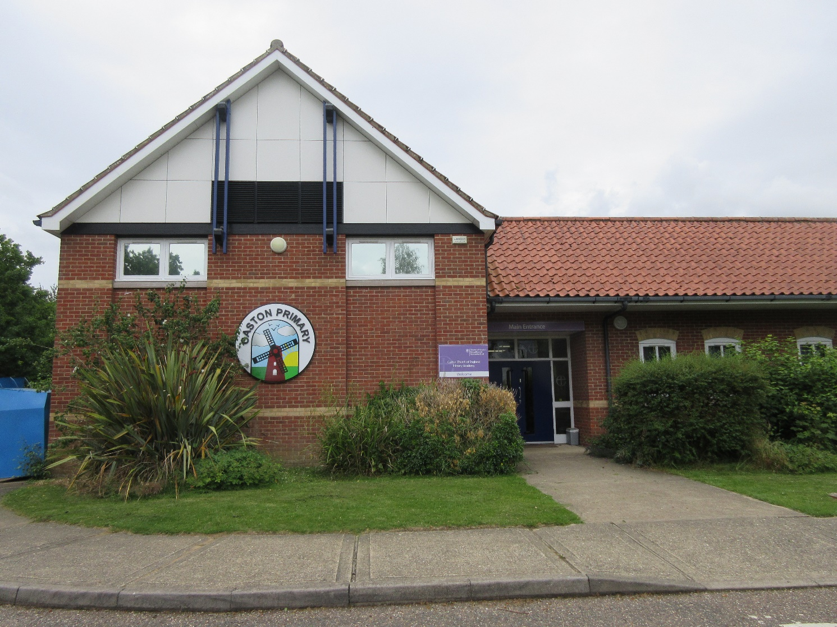

This is our school
Caston C of E Primary Academy

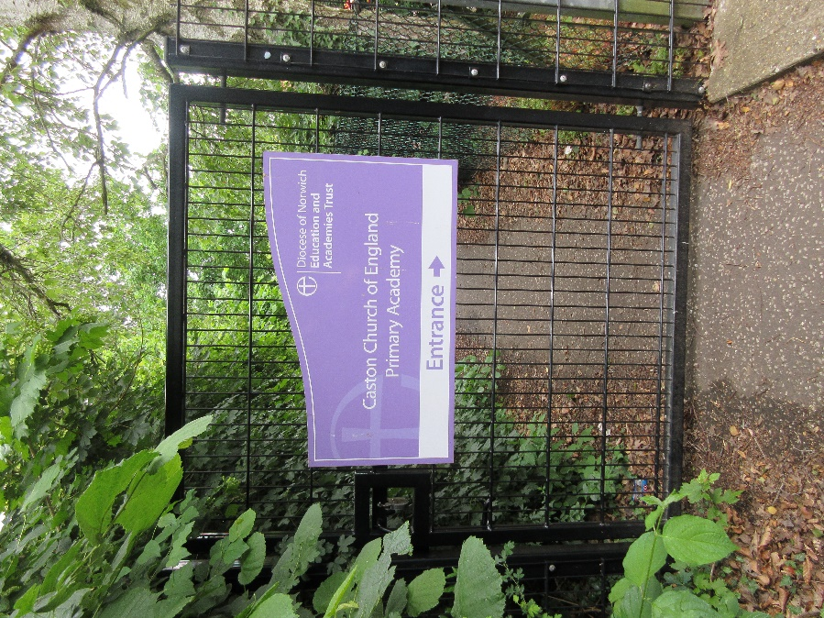
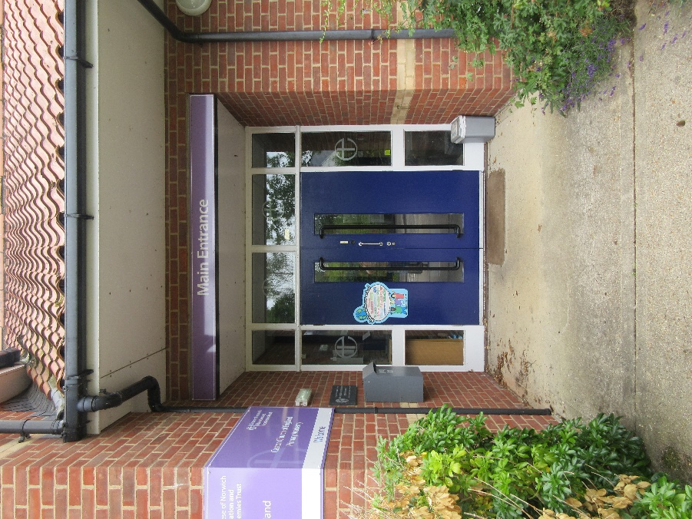

This is the front door to our school and the gate that you will see when you come to school every morning.

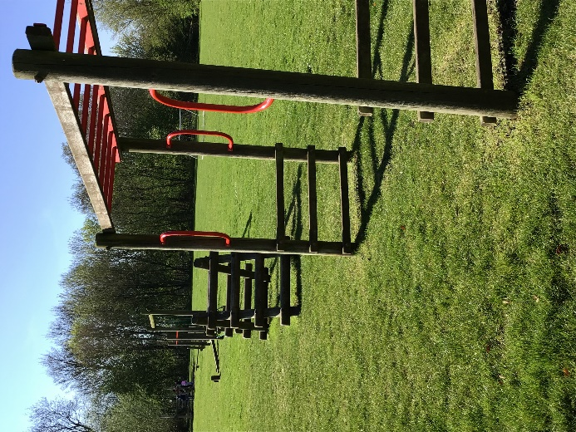
This is the trim trail. We like playing on it.
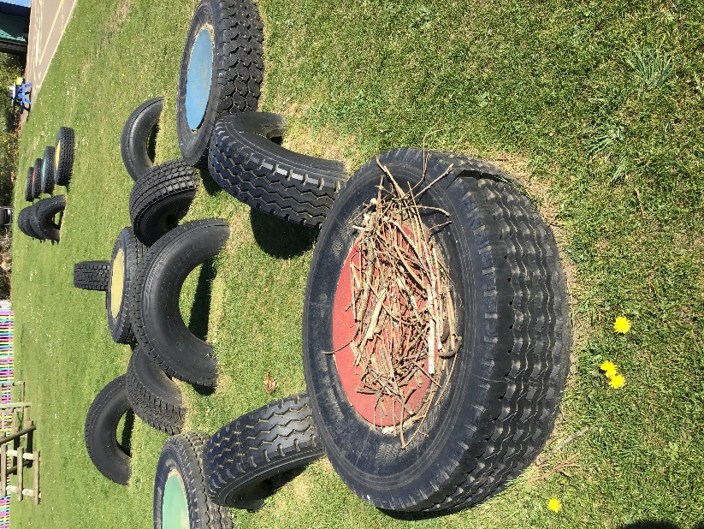

.

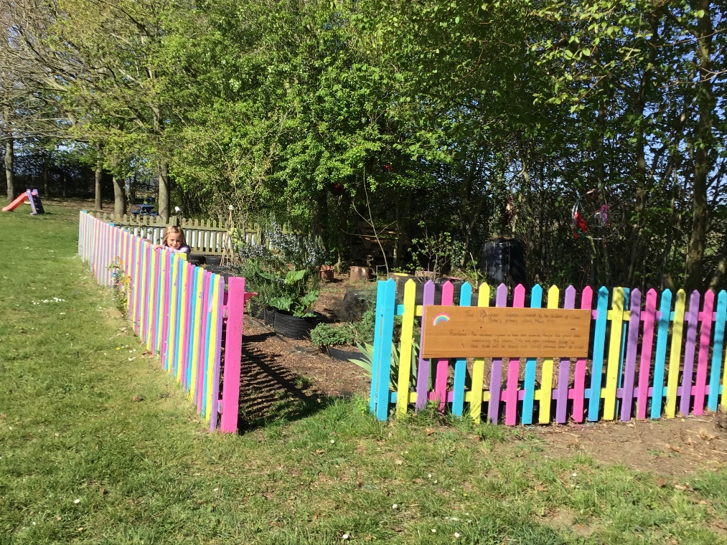

This is our Rainbow Garden. We all take turns to looks after the plants and the wildlife.

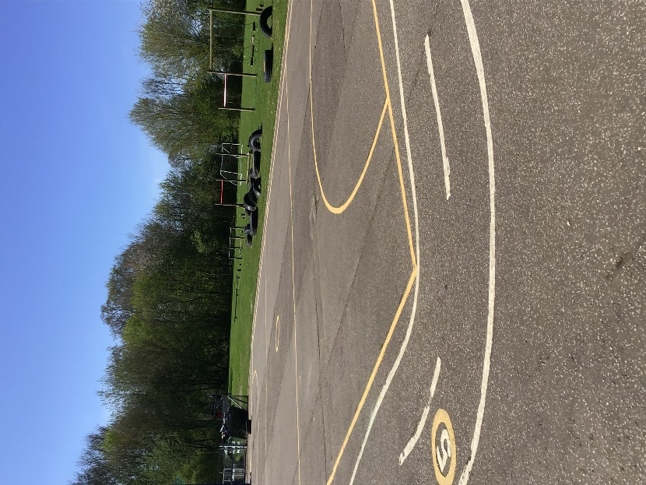
At the end of playtime and lunchtime the whistle blows. We line up with our class on the yellow line before we go inside.

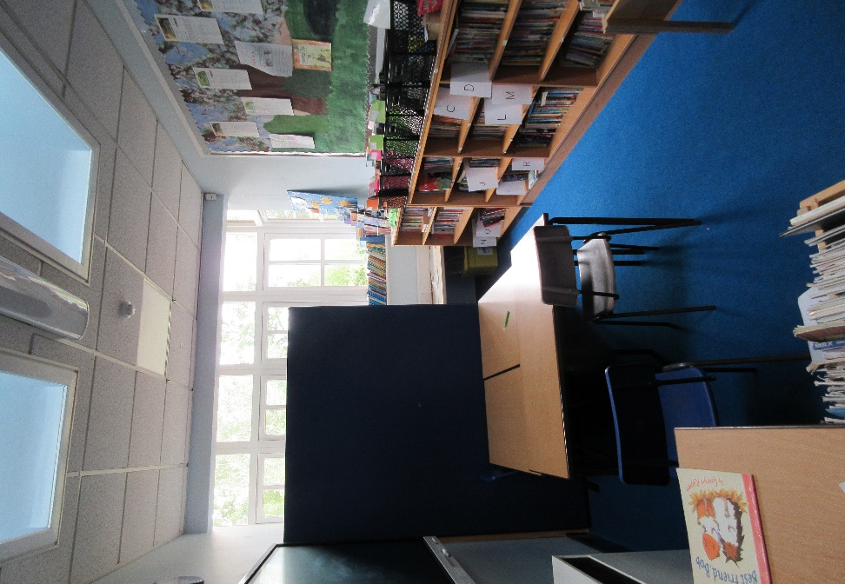

This is the library. We come in here to choose some fun books to read and share.

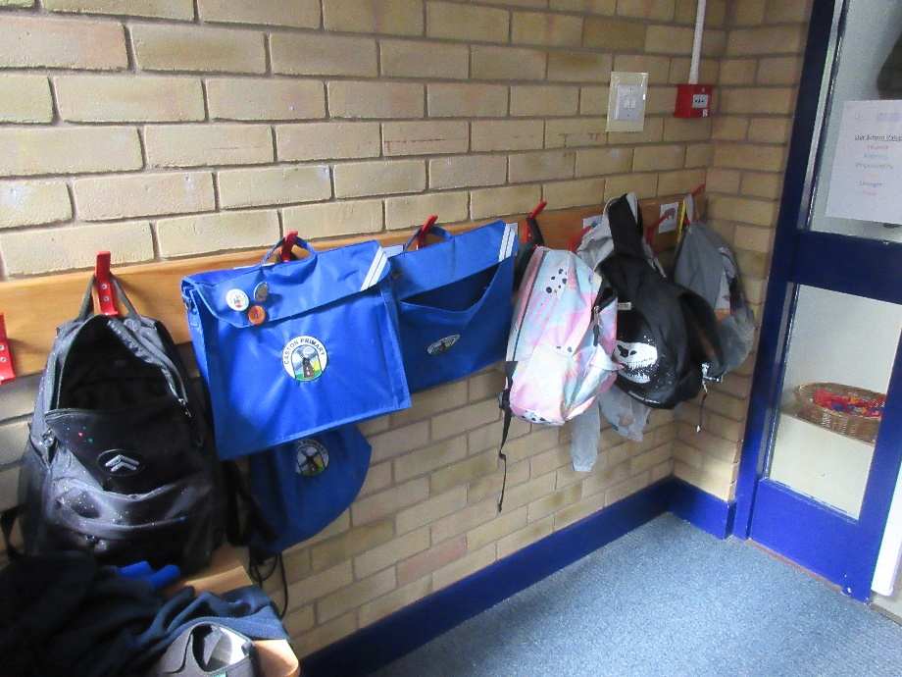

This is our cloakroom where we hang our coats, wellington boots and PE bags.

This is our classroom.
We put our work on the wall and things to help us learn.
There are lots of fun things to do in our classroom.

.
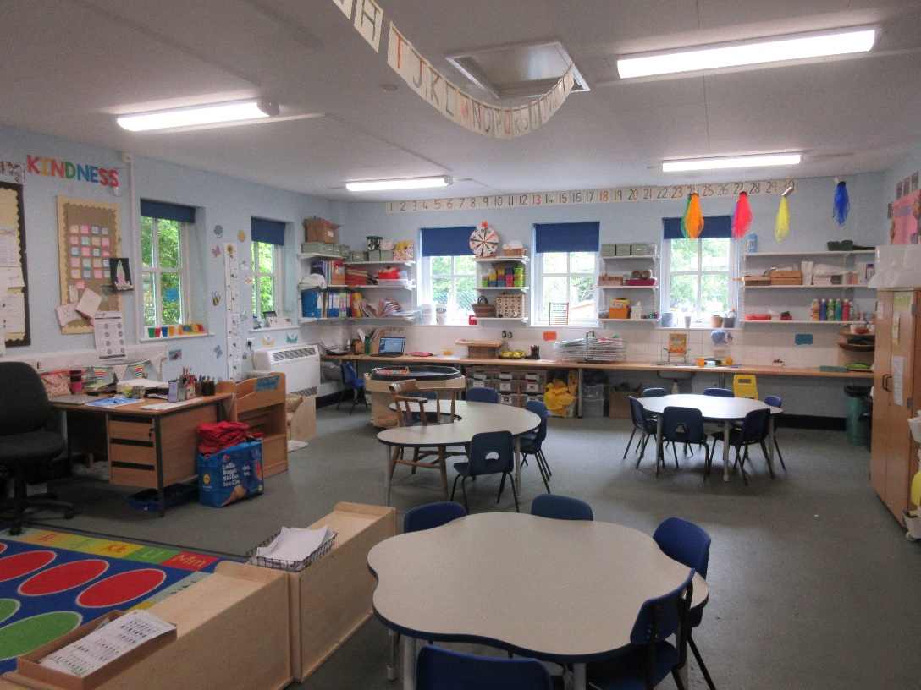

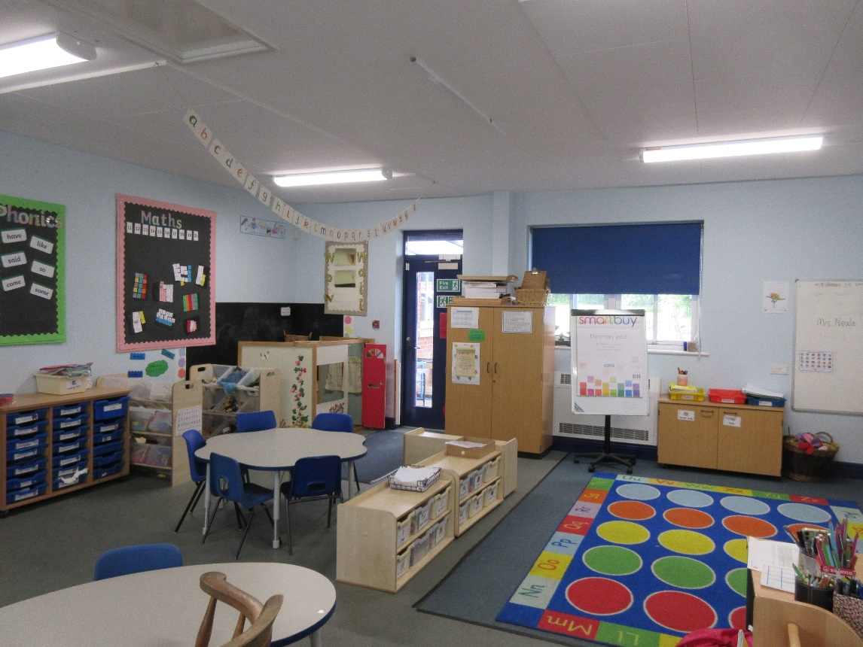

This is our outdoor area.
We like to have lots of fun here

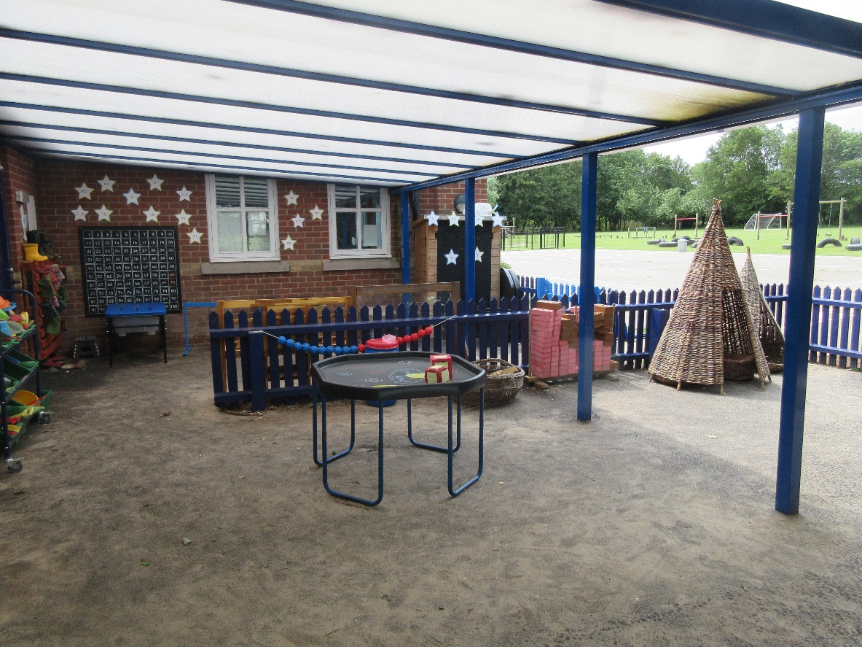

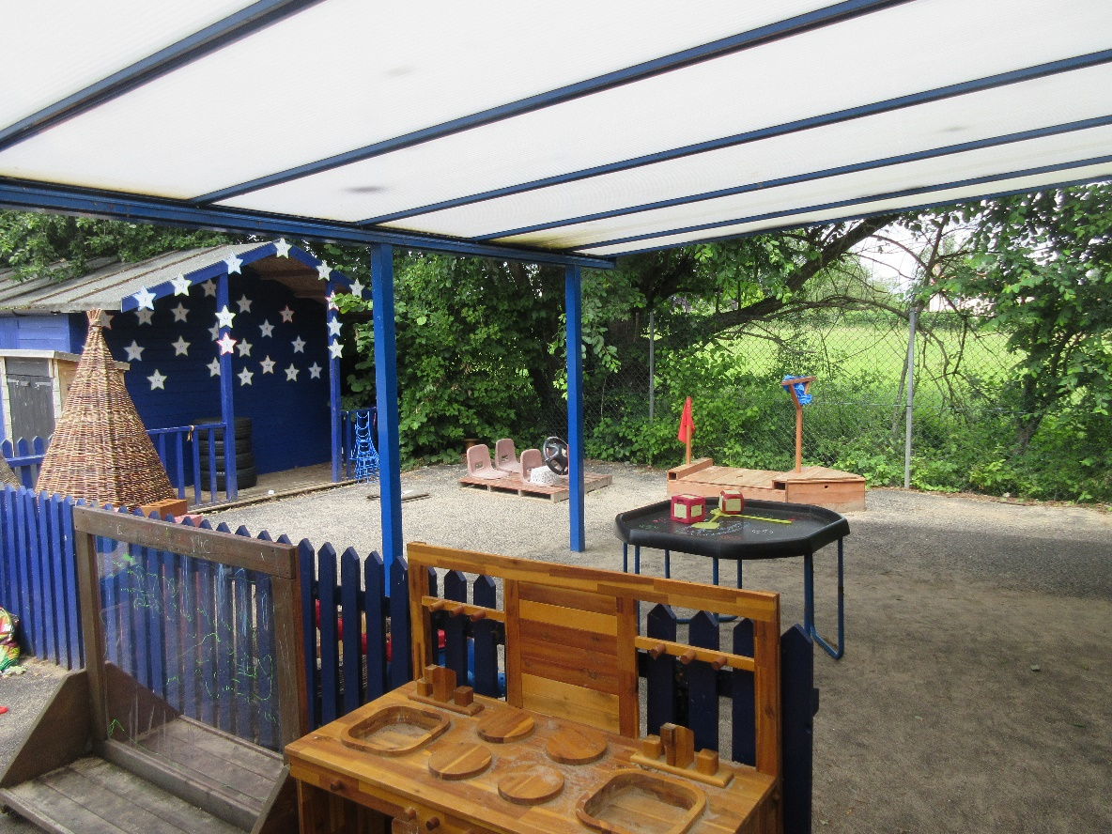

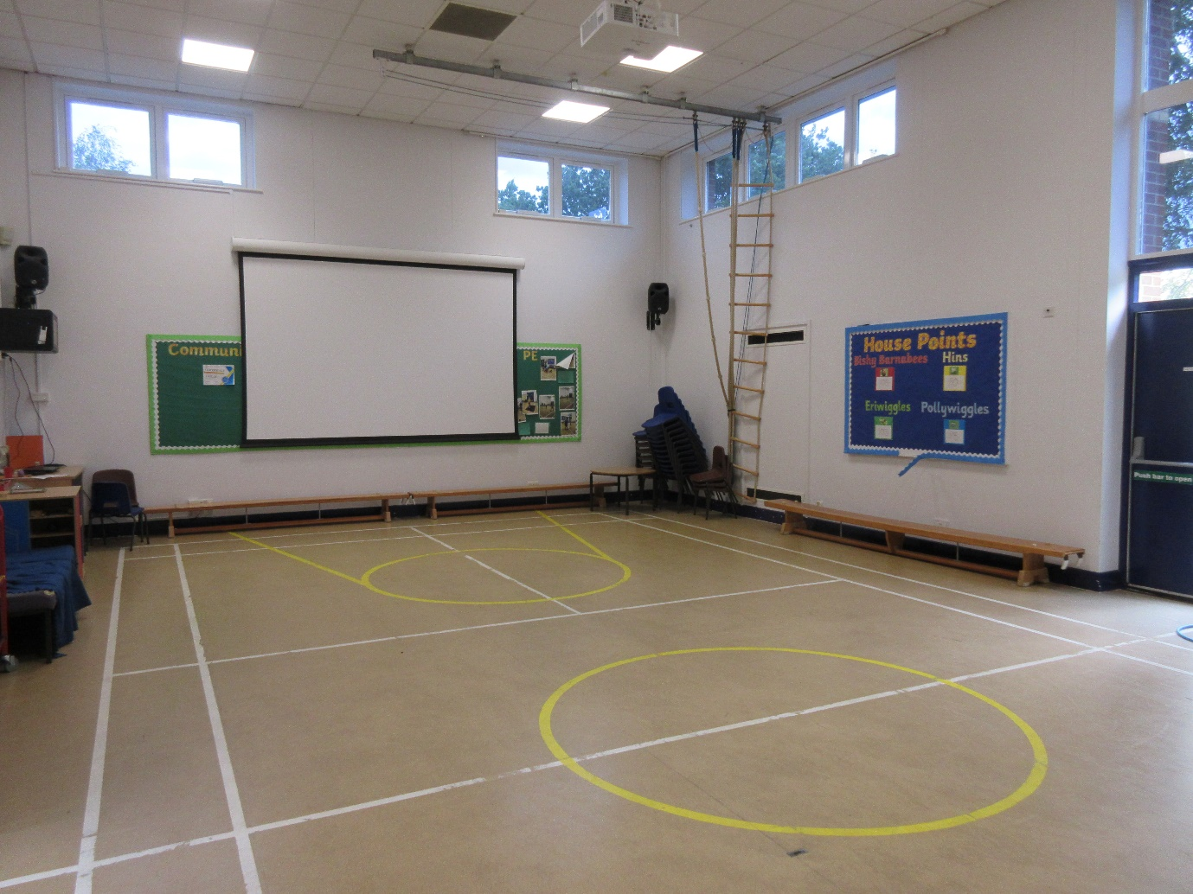
This is the hall. We come in here for Collective Worship and sometimes for PE. We also eat our lunch here.
People who I will see around school.
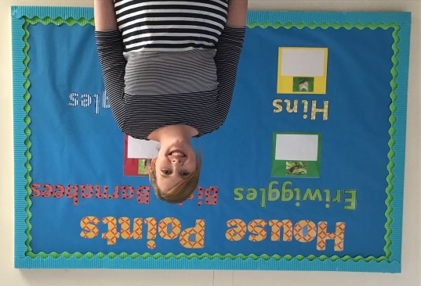
This is Mrs Disney our Head teacher.

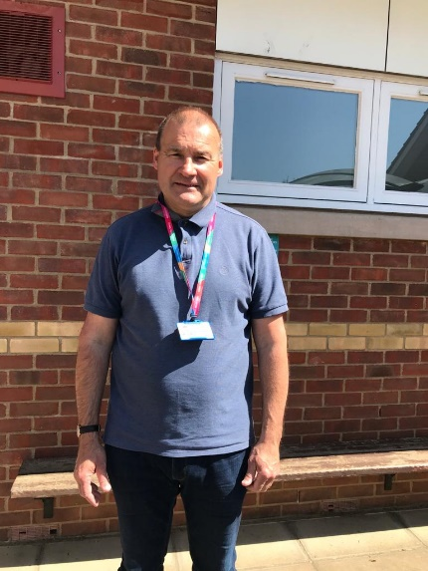
This is Mr Halmshaw who is our Head of School and your class teacher



This is Miss Lindop she is your class teacher.

We look forward to getting to know you in September.

