


Caston C of E Primary Academy
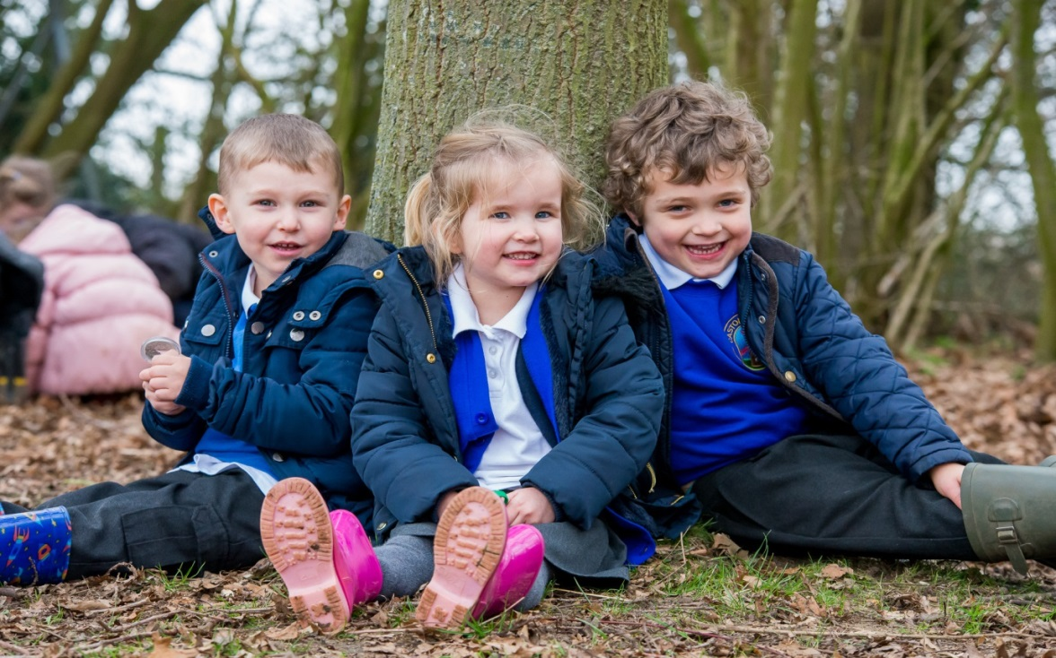


The Dove Federation
“Ask and it will be given to you; Seek and you will find; knock and the door will be opened to you.” Matthew 7:7
A warm welcome from the Head Teacher
Dear Parents and Carers,
Thank you for choosing to look at Caston Church of England Primary Academy for your child. On the 1st of November 2020 we became Caston C of E Primary Academy when we joined the Diocese of Norwich Education and Academies Trust (DNEAT).
Our children have created a video tour of our school, which is available on our website, for you to view and share with your child. We will also hold open afternoons where you can ask questions and meet myself and the reception class teacher. In the meantime, if you have any questions or want to find out more about us please do not hesitate to contact the school.
As a Church of England School, we have great links with our local Church. The School and its pupils reflect the dedication to the Christian values and beliefs we hold at the centre of our ethos.
Starting a new school is the beginning of a three-way partnership between Parents/Carers, the School, and the Pupils. We want this partnership to be strong in supporting the educational journey of all of our children into well-rounded, thoughtful and caring individuals who can find their way in the world.
We would like parents to be fully involved in the life of the school and to support their children throughout their time here.
We understand that all children are individuals and work in different ways and at a different pace to others around them. As such, we aim to be an inclusive school where everybody can successfully grow in all aspects of school life.
You will find most of the information you need here in this prospectus – more information is available on the website. However, if you still have any further questions, please contact me at school.
We look forward to welcoming both you and your child into our school and hope that they will be happy here.
Mrs Sarah Disney

Closures and Contacts
School Closure
The school rarely closes because of bad weather, but if particularly bad weather is forecast, please check the school closures daily by way of:
Local radio - BBC Radio Norfolk 95.1FM & 104.4FM
Norfolk Council’s website – www.schoolclosures.norfolk.gov.uk
The school’s website – www.caston.norfolk.sch.uk
Contacts:
Chair of Governors Mr Bruce Gordon
Executive Head Teacher Mrs Sarah Disney
Head of School Mr Marcus Halmshaw
Federation Support Manager Mrs Helen Jeffries
School Secretary Miss Sharlee Willis
Chair of Friends Mrs Susan Stubbins
School website: www.caston.norfolk.sch.uk
School email: office@caston.dneat.org
Chair of Governors email: office@caston.dneat.org
Address:
Caston Church of England Primary Academy
The Street
Caston, Attleborough
Norfolk, NR17 1DD

Coming to School

Open Days
Usually Parents and grandparents are invited to see the school in action at least twice during the year. We will let you officially know when this is going to happen. For Reception children we will wait until the children have settled in before inviting you to the school for an open morning.
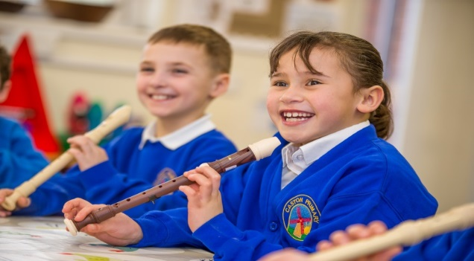
Parents’ Evenings

Parents’ evenings are held twice per year. During the Autumn and Spring terms there will be the opportunity to speak to the teacher to discuss your child’s progress. At the moment these are being held virtually. In the Summer term you can book an appointment if you wish to do so.
Collective Worship
We hold a daily act of collective worship. As part of this we look at our school values which change on a half termly basis.
Whenever possible we invite the local church into school to lead our collective worship. For key festivals during the year we visit the local church and hold a special celebration at the church.
Once a week (usually a Thursday), starting at 3.00 p.m., we celebrate the successes of the previous week with all the children and parents in our hall. Parents/carers are invited if your child is receiving an award.

School Uniform

The school has a uniform which we encourage the children to wear at all times. You can purchase sweatshirts, cardigans, book bags etc. from Birds of Dereham

https://www.birdsofdereham.com/shop/category/caston-c-of-e-va-primary-762/

Boys and Girls
Royal blue sweatshirt and cardigan with school logo.
Grey trousers, skirt, shorts or pinafore.
White polo shirt
Grey or white socks or tights
Girls summer variation – Blue and white checked summer dress
Black school shoes

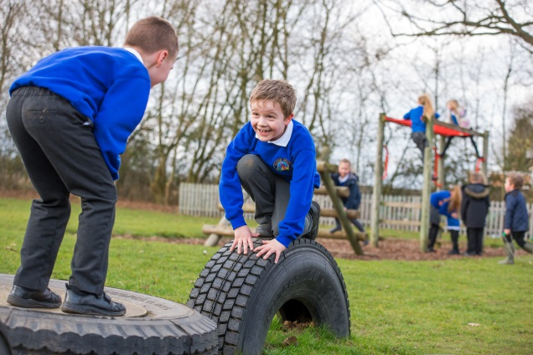
Art and outside clothes
It would be appreciated if parents could provide protective clothing for use during art activities. An old shirt for the older children and a plastic apron for the younger children will lessen the damage to clothes. As outdoor learning is going to be more a part of our curriculum we would like all our children to have Wellington boots and water proofs at school. Please make sure that ALL items are properly labelled, so lost items can easily be recognised.

Sportswear
For PE and most games children should wear shorts, a team colour or white T-shirt and gym shoes are needed. For indoor activities they should go bare-footed or wear clean trainers. During winter months children will be allowed to wear track suits and trainers outside. Outdoor footwear should come in a plastic bag.

The School day

The school day usually starts at 8:50am and ends at 3:20pm. Doors open at 8:45am.

Arrival
Children should arrive at school between 8:40am and 8:50 am when there will be start of the day activities. Children enter and leave school via the playground, please do not use the main school door. Parents are encouraged to leave the playground as soon as possible to allow the gates to be locked and the teachers to take the children into their classrooms. Children should not arrive before 8:45am, unless supervised and we cannot accept liability for those who do.

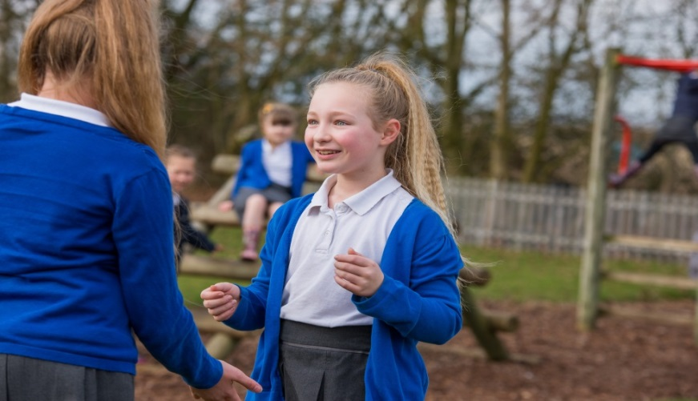
Lunch Time
Our school lunches are cooked by Nourish at our partner school Parker’s. We can certainly recommend them as both quantity and quality are good. There is a variety of choices every day including jacket potatoes and vegetarian meals. For more information contact the school office.
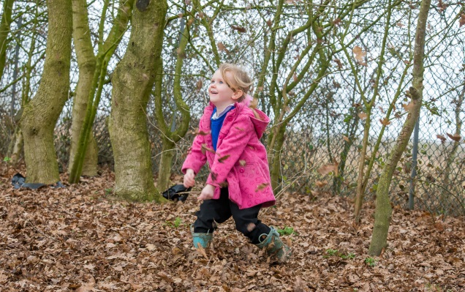

Before and After school clubs
We have a breakfast club and an after-school club which run every day during term time. Breakfast club runs from 8am – 8.45am. After-school club runs from 3.20pm – 5.45pm.

Your role as a parent / parental involvement

Volunteers
We welcome volunteers in our school to support children with their learning and with activities such as school trips. If you have any talents you want to share with our children, please contact the Head Teacher.
As a school we have a friendly Friends committee who are working incredibly hard to get extra funding in for the school. If you would like to become involved as well please contact our Head Teacher or contact Miss Willis.
If you are interested in volunteering on a regular basis, you will need a DBS check. Please contact the school office in the first instance.

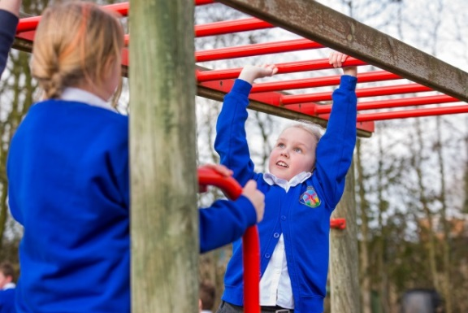


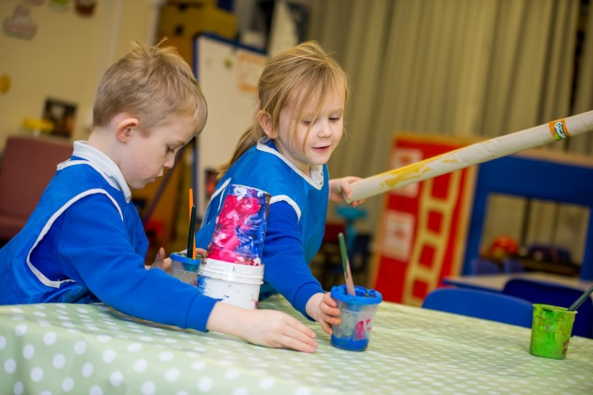

Homework
Evidence has shown that parents have more influence on children’s learning than anyone else. Therefore, we would ask you to plan some time to support your children daily with their reading, online homework tasks, spellings and any other homework tasks. The homework tasks have clear objectives, yet can be completed in any way the children like.

Teaching and learning

Our Curriculum Rationale
School Vision
“Ask and it will be given to you; Seek and you will find; knock and the door will be opened to you.” Matthew 7:7

School Values
Unity, Kindness, Hope, Strength, Respect, Responsibility
School Ethos
- To give each child experience of a wide programme of study including the requirements of the National Curriculum
- To make provision for all pupils to develop their academic, moral, social and cultural potential.
- To foster an attitude of care and respect for others through the religious and moral education and through the general ethos of the federation.
- To develop skills appropriate to the individual child’s capabilities.
- To stimulate and develop the child’s interests and capabilities.
- To encourage care and respect of the environment and the local community, alongside an awareness of the wider community in which we live.
- To provide equality of opportunity and equality of regard for every member of the federation community.
- To enable pupils to learn a wider range of skills

Aims of our Curriculum
Through our curriculum teaching, we have the following aims for our pupils.
These are:
- To provide challenge, enjoyment, personalisation and progression
- To provide children with the skills they need to succeed
- To be able to reflect and evaluate

- To develop pupils’ independence so that they are able to apply their learning independently
- To develop a secure subject knowledge which they are able to apply and retain
- To develop and broaden pupils understanding of language and vocabulary and be able to apply this to everyday conversations and learning
- To encourage pupils to take pride in all that they do

Knowledge Rich Curriculum (Knowledge Led)

At the Dove Federation we have designed a curriculum which focuses on the knowledge we wish to teach our children. Our aim is to ensure that the knowledge which is taught is in-depth, can be recalled and applied within learning. Language acquisition is a key focus, we wish to develop and enhance pupils understanding and use of language through the curriculum.

Wherever possible we try to ensure that the knowledge that we teach is influenced by the pupil’s interests. All of our learning is led by the National Curriculum and we use progression maps to ensure that the National Curriculum is being effectively covered.

How we deliver our curriculum
At the Dove Federation, each National Curriculum subject is timetabled into a weekly timetable to ensure that there is adequate coverage. In order to further enhance and allow for further opportunities for curriculum coverage we try to plan curriculum theme days for religious education, humanities, science and the arts. We also try to plan engaging school trips, which enhance the curriculum we are teaching.

How we teach
We try to use a variety of different ways to teach across the curriculum to ensure that all learning styles are catered for. As it, usually takes at least 3 times of hearing, seeing and doing something for a new skill and knowledge to be retained we try and re-visit previous learning as often as possible. Whenever possible we try to make lessons practical, investigative and active and try to create a good balance between this style of teaching and written work. This means that not all learning is recorded in books. We try to keep evidence of the practical work that we do through creating displays of our work and putting photographs of our practical work in a whole class floor book.
In line with our school vision we try to encourage and foster individual talents and promote opportunities for pupils to use these within our wider curriculum and extra-curricular activities. With this in mind all pupils within Key Stage 2 have the opportunity to access specialist music teaching as part of the weekly music lesson and also extra tuition. All pupils during the course of the academic year receive specialist teaching during their physical education lessons and have the opportunity to attend sports clubs.

Communication

Letters Home
Whenever possible we always try to send our letters via email and communication via text message and also on our school website. Please ensure that the office has your up to date email addresses and mobile telephone numbers. If you wish to receive the letters by paper format please let the office know.


Data Collection
Every year we will ask you to confirm that the information we hold about you and your family is

accurate and up to date. Please let us know if anything changes, as it is essential in case we need to contact you during the school day.

Website
Our website is a useful source of information about our school, containing essential information regarding pupils, parents, our curriculum and a list of important dates. It is regularly updated so please do use it to check for any information you might be looking for.

www.caston.norfolk.sch.uk

More Information

Sickness Absence
If your child is not well enough to attend school, please let us know before registration. The school secretary will, as part of our cluster policy, ask the reason for absence. There is a leaflet available at the office to guide you in case you are not sure your child should come into school. Most of the time we find though that children feel better as soon as they are in school. If your child is ill for more than one day please contact the school every morning before 9:00am. This is for safeguarding reasons!
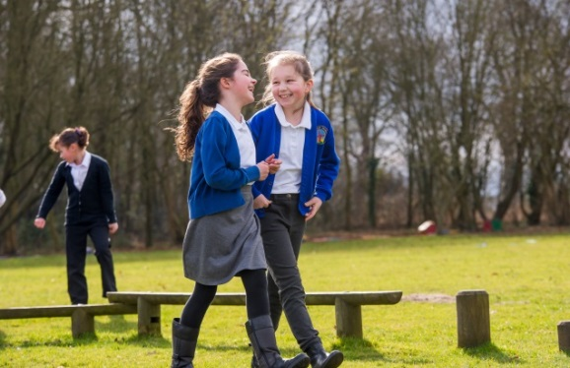

Holidays
A good attendance, more than 97%, will help improve your child’s success at school. Taking time off for a holiday during term time will not be authorised, except in exceptional circumstances.

Medicines
When it is essential for your child to have medication during the school day we require a signed form from you as a parent, stating what the medicine is, who it is for, the dosage, when to give it and for how many days. These are available from the office.

Injury or Illness
When your child is hurt or becomes unwell at school we will administer first aid. In case of a concern we will contact you. If we are unable to contact you, we will contact a health professional. Please make sure your address and telephone numbers are up to date!

Swimming
Pupils in Year 3, 4 and 5 usually attend weekly swimming lessons every Friday afternoon during the Autumn and Spring terms.
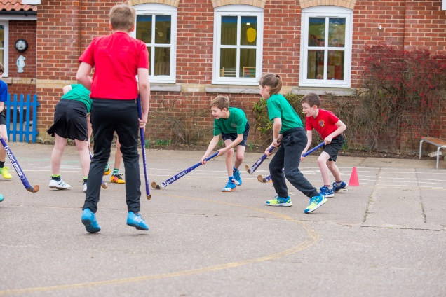
Swimming lessons take place at Thetford Leisure Centre where a swimming instructor is in attendance. Pupils are also accompanied by school staff and parent volunteers.
Complaints
We recognise that complaints might sometimes occur and we take them seriously. If you have a complaint, then please speak to the teacher first. If you wish to take the matter further speak to the Head Teacher. If the matter is still unresolved, please ask for details of the Complaints Procedure.
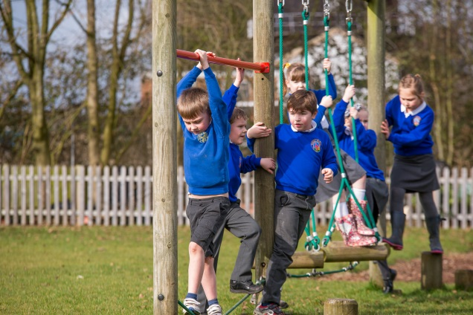

Valuables and Jewellery
Valuables should not be brought to school and we will not accept liability for any loss or damage to any such valuables. The only jewellery pupils are permitted to wear are watches and small stud earrings. They must be removed before PE, games and swimming. The taping-over of earrings will only be permitted in the initial weeks following an ear piercing, except for swimming where all earrings must be removed.

Address:
Caston Church of England Primary Academy
The Street
Caston
Attleborough
Norfolk
NR17 1DD

Tel: 01953 483304
Email: office@caston.dneat.org

