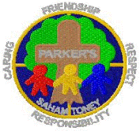

The Dove Federation

Ideas for Lunchboxes

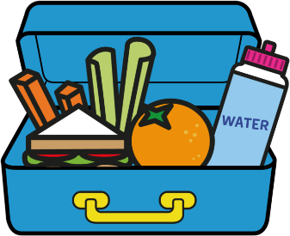
To support parents to implement our healthy lunch box policy, we have put together a few ideas for what to include in children’s lunchboxes. A healthy lunch helps your child maintain a healthy weight, concentrate better, behave better and therefore learn better.
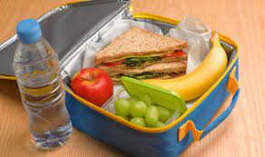
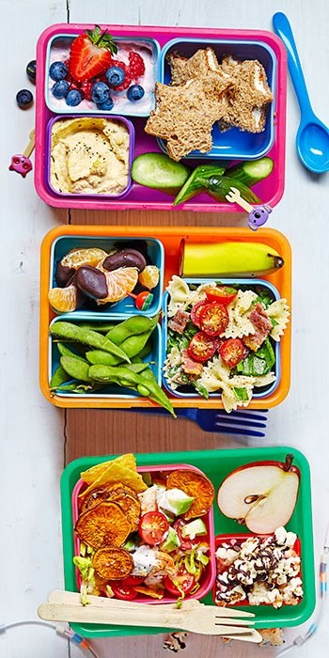
Sweet things

• Tinned fruit/ fruit cocktail (in fruit juice)
• Fruit salad
• Fruit shapes/ strings
• Berries and cherries
• Dried fruit e.g. raisins
• Yoghurts (no chocolate in)
• Meringues
• Pots of rice pudding
• Pots of low fat custard
• Cereal bars (no nuts)
• Flap jacks
Please limit high fat foods e.g. sausages, pies and pasties to only once or twice a week as a treat.
Sandwiches etc
• Wraps—chicken, ham, beans, cheese and salad
• Egg
• Salad
• Tuna, sweetcorn, mayonnaise
• Pieces of baguette
• Crackers and cheese
• Rice cakes
• Bread sticks
• Small pots of sandwich fillers
• Home made pizza on pitta bread • Piece of quiche
• Cheese scone
• Toast

Please do not include:
• Chocolate/ chocolate spread/ chocolate chips
• Nuts
• Sweets
• Fizzy drinks
• Biscuits (unless home made)
• Cakes (unless home made)

Drinks

• Water
• Yoghurt drinks
• Diluted low sugar squash
• Fruit juice (not every day)
• Smoothies
• Milk
• Milkshakes
Savouries

• Hard boiled eggs
• Low fat / baked crisps
• Samosas
• Bhajis
• Chapattis
• Small pots of seeds
• Cheese and pineapple
• Vegetable sticks
• Small pots of sandwich fillers
• Dips
• Small wrapped cheese e.g. baby bel
• Pasta salad
• Potato salad
• Cous cous
• Noodles
• Rice
• Coleslaw
• Falafel
• Soup in a flask

