Dove Federation
Vision Statement for Mathematics

“God has given each of you a gift from his great variety of spiritual gifts. Use them to serve one another.”
1 Peter 4.10

At the Dove Federation (Parker’s CE VC Primary Academy and Caston CE VA Primary Academy) the purpose of education is to develop our children and community members, intellectually, physically, morally, and socially according to Christian principles, encouraging and fostering their individual talents.
We provide a broad and balanced, knowledge rich curriculum which is stimulating and challenging, catering for all. It aims to give children secure subject knowledge and skills, an understanding of language and subject specific vocabulary, an ability to reflect and evaluate their work as well as promoting creativity, independence and encourage lifelong enjoyment of the subject. Our curriculum provides opportunities for children to explore and engage with ideas and experiences outside their everyday life experience.
In our federation Mathematics is valued as part of our pupil’s entitlement to a broad and balanced curriculum which is accessible to all. Mathematics is taught in all years groups on a daily basis. Mental maths, times tables and number bonds are taught on a weekly basis.
Our maths curriculum aims to develop pupils reasoning, fluency and problem solving skills. In line with the National Curriculum we want pupils to become fluent in the fundamentals of mathematics, including through varied and frequent practice with increasingly complex problems over time, so that our pupils develop conceptual understanding and the ability to recall and apply knowledge rapidly and accurately. We also want pupils to be able to reason mathematically by following a line of enquiry, conjecturing relationships and generalisations, and developing an argument, justification or proof using mathematical language. Through their learning we aim for pupils to be able to solve problems by applying their mathematics to a variety of routine and non-routine problems with increasing sophistication, including breaking down problems into a series of simpler steps and persevering in seeking solutions.
A key focus of our programmes of study is retrieval practice.
We place emphasis on language acquisition across our curriculum areas. Our children learn about the language of Mathematics, developing their understanding of its own vocabulary and the meaning of specific words. We want children to have the appropriate vocabulary to express their knowledge and understanding of Mathematics.

EYFS Year 1 and 2
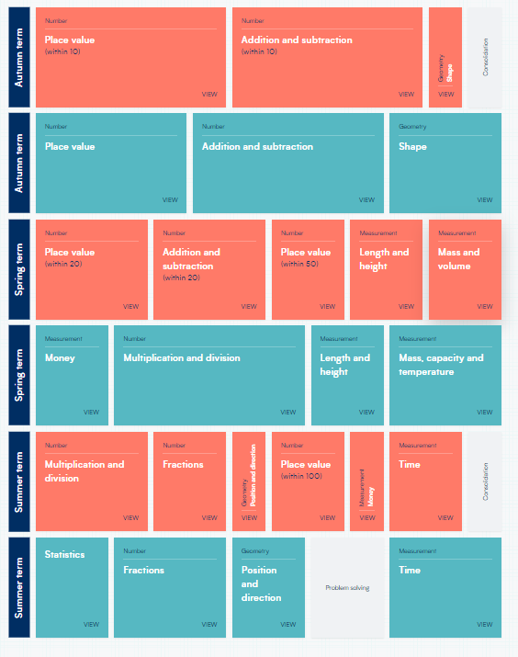
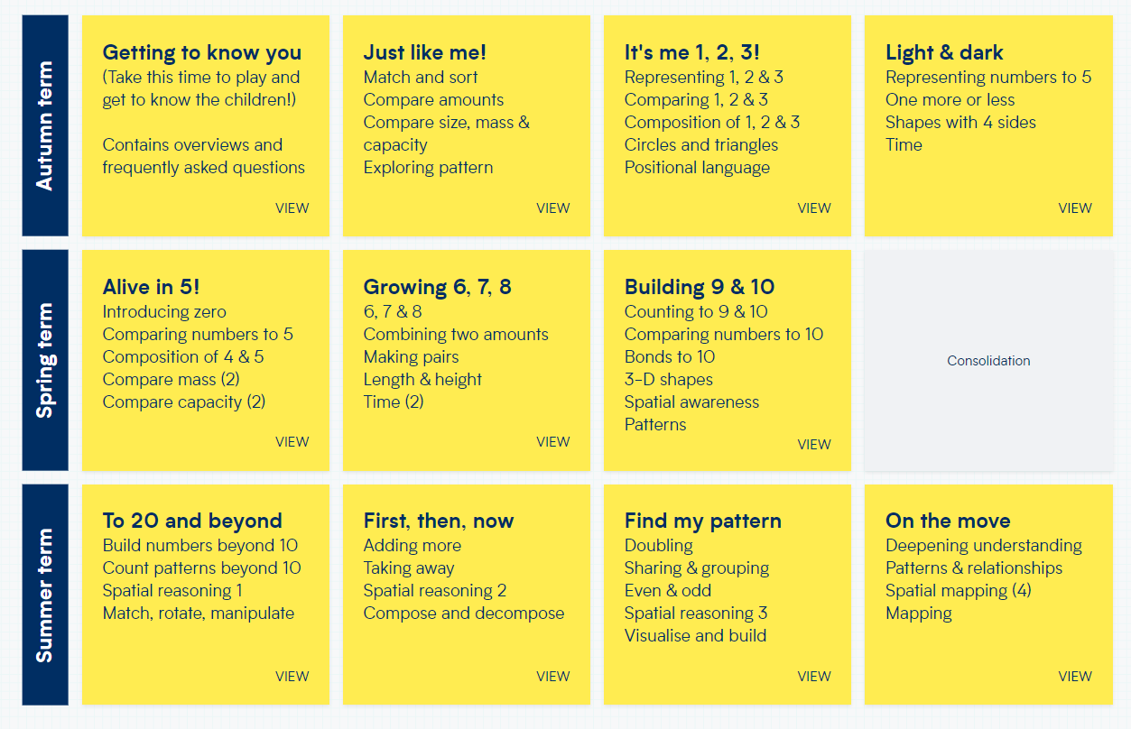

Year 3/4 Year 5/6
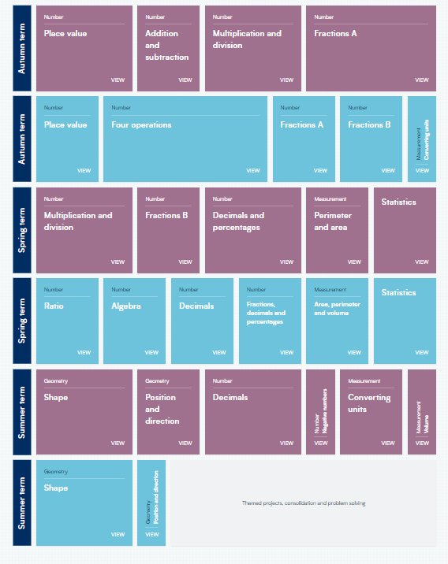
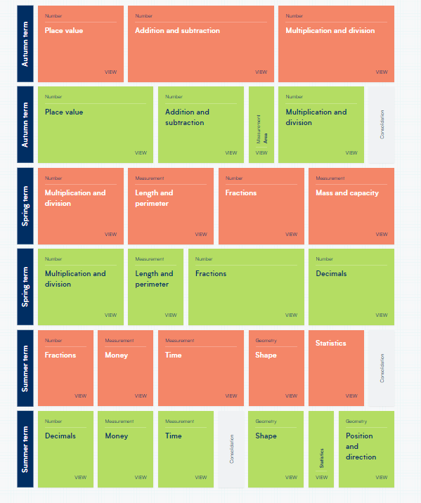

Key objectives that would be covered in each unit of work

EYFS


